CovidSim Primer

Public Domain @EC_GO

INTRODUCTION

This is a Javascript program intended to be run in an Internet browser. Typically, you would download the html file, locate it in your directory, and right-click to “OPEN WITH……” enter your favourite browser.

It takes up a canvas of 2000x1000 pixels so it may not look reasonable on phones.

INTENT

Currently, it is in the class of Stochastic Agent Based Models, intended to be a dynamic modelling tool to investigate the progress of contagion-based epidemics in confined populations of up to 7,000. This Agent-Based Model runs on synchronous time, so that all transitions are considered at once, rather than asynchronously, in which transitions drive local times.

ELEMENTS OF THE CovidSim Model

The population consists of ENTITIES which have a small number of states with simple rules for their behaviours and transitions from state to state.

The discrete nature of the time steps permit statistics to be gathered and displayed at each step, if desired. The movement of the entities are shown on the Action Field at each step, in their states.

The Entity States are:

GREEN (think uninfected persons)

YELLOW (think infected but INCUBATING and not infectious)

BLUE (think infected and INFECTIOUS)

RED (think diagnosed either by symptoms or positive tests)

ORANGE (think diagnosed and isolated to remove from general circulation)

RULES AND TRANSITIONS

The dynamics of this model are based on three types of rules: movement, size, and duration

MOVEMENT: RULE: if two entities overlap after a step, there may be a state change from GREEN to

YELLOW if one of the entities is GREEN and the other is BLUE or RED

This is a random walk using a Pareto-like distribution in the X and Y directions for

magnitude, and a random selection of UP/DOWN and LEFT/RIGHT. This means that the

Probability for a magnitude of movement is much more likely close than far away.

The activity field are boundaries, so the entities do stay within the field.

There is a general setting for MOVEMENT, which affects all entities, but BLUE entities

and their successors amplify the setting while GREENs are relatively sedentary.

The general setting can be changed during execution as a parameter, while the extent of

their differences can be modified in the Javascript program.

SIZE: RULE: The radius of an entity is its Hazard Size and represents the likelihood of overlap.

The model is based on contagion, which means that after a step, every entity checks if it

overlaps with another. If one is BLUE or RED (infectious) and the other is GREEN

(uninfected) then the GREEN transitions to a YELLOW state (incubating).

Clearly, the larger the radius of an entity, the more likely it is to be involved in a

collision. For BLUES and REDS, these represent the degree of infectivity.

For GREENS (uninfected) the size represents the risk of being infected….the smaller,

the lower the risk. The Hazard Size in the CovidSim menu of parameters and can be reset at any step. This gives CovidSim the power to simulate INTERVENTIONS.

As it represents the risk of being infected, CovidSim has built in the capability of

using Age-Group as an influence on risk.

Age-Groups can be entered as desired. The default currently is the demographics of

BC for 2019. For each Age-Group, there is its % of the population. In addition, for each

Age-Group, there is its % of all Covid cases. From this, the “Model Risk” for the Age-

Group is calculated. The case ratios are an average of Italy and Spain, April 2020.

For example if the age 50-69 age group is 30% of the population, and also 30% of the

Covid cases, the Model Risk is 1. However, if the case % is only 15%, then the Model Risk

is 15/30 or 0.5.

After the population has been defined (say 100), and the Age-Risk has been selected,

CovidSim then allocates to each person an Age category in keeping with the population

demographics, with a Model Risk as described, and an appropriate adjustment of its

Hazard Size.

Another table of risks exist, which could be used for Ethnicity, or for Co-morbid

conditions. To use this properly, we have to know how to combine two risks, which is at

present undefined in CovidSim. SO PLEASE DON’T USE IT YET.

You will notice that sizes tend to remain the same once set, no matter the state, except

for ORANGE. This is intentional but can be changed later within the program.

DURATION: RULE: GREENS stay GREEN unless infected (overlap with BLUE or RED)

YELLOWs persist for a duration which is a stochastic parameter (incubation

period - then they turn BLUE

BLUEs persist for a duration (infectious period) then turn RED

REDs persist for a duration (also infectious) then turn ORANGE (isolated and out

of circulation)….they are resized to 6 pixels for no particular reason

MIXED: For BLUEs, there are 4 choices for varying infectivity with time:

1. Constant – as set in turning BLUE from YELLOW
2. For the duration of being BLUE, increase linearly to double the size
3. For the duration of being BLUE, increase linearly to triple the size
4. For the duration of being BLUE, at each step modify its current size by factor X. This supports decreasing as well as increasing degrees of infectiveness.

TRANSITIONS: These are simple – GREENS to YELLOWs to BLUEs to REDs to ORANGEs

They follow the rules for duration and collision as above, based on risks and movements

OPERATING CovidSim:

As described above, use right click to open with a browser. Then you are faced with the field of action, and the menu of parameters:

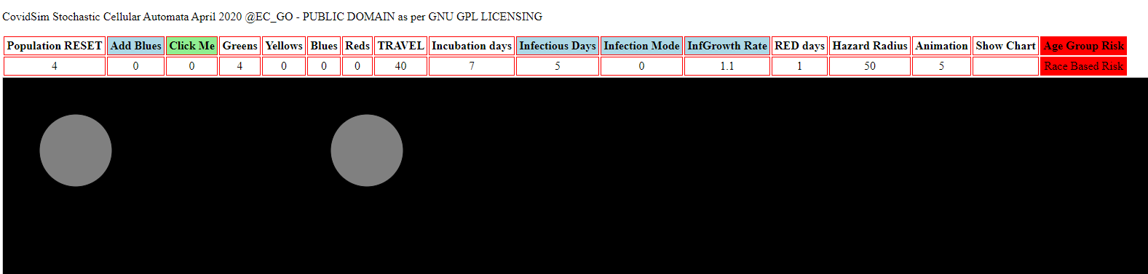

We will go through this step by step, with focused parts of the menu. Leet’s begin with the left.

To begin with, the TOP ROW are button selectors, while the bottom row are displays for parameters and entities.

CLICK ME - EVERY STEP OPERATES THROUGH THE GREEN BLICK ME BUTTON

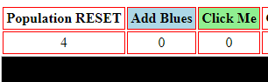

SELECT POPULATION RESET

Although you can start immediately with the default number of entities, and choose “CLICK ME”, it is better if you first select Population, which in general RESETS everything. This means you can have multiple trials without having to restart the program.

In general, perfect squares are easier to handle. Also, you might like to set your browser to 80% zoom to see the entire field of action easier. I would suggest 16, 36, 64, 100 as a start before diving into 3600 or 4900 entities.

ADD BLUES

The population always starts out uninfected (GREEN). If you wish to model an epidemic you have to introduce BLUEs (these are called “VISITORS” and handled differently depending on the Age-Risk selection).

Choosing 1, 2 or 3 will give you a sense of epidemic growth based on physical contagion.

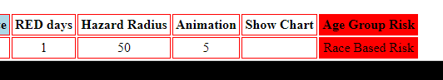CHOOSE AGE-RISK

This is the top RED button on the right side of the menu. If you choose it, you will be essentially be conducting a census of the population. If visiting BLUEs were introduced prior to this step, they will be included as part of the population and assigned to an age group.

However, if the census was conducted already (Age Risk button selected) and then BLUEs are added, they cannot form part of the census so will be counted as Others, though still following the rules for BLUEs.

Clicking on the AGE GROUP RISK button brings up an overlay menu and table, lik this:

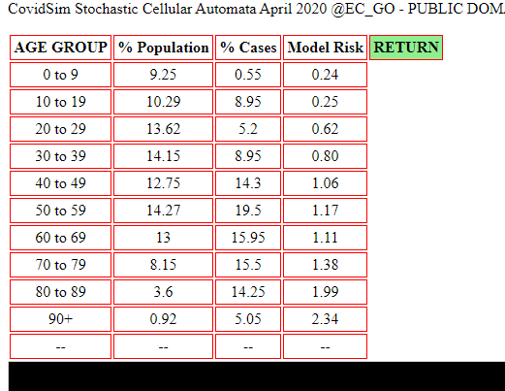

For simplicity, you cannot enter data into individual cells but only into a column all at once. For example, if you don’t like these default values, you can click on “AGE GROUP”, and a prompt will ask you to enter all the Age-Groups you want as a single list, separated by commas. For example, to reproduce the above,

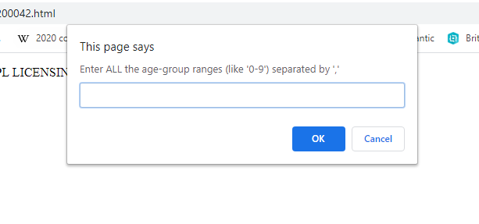

The list entered would be (no quotes, just commas between):

0 to 9, 10 to 19, 20 to 29, 30 to 39, 40 to 49, 50 to 59, 60 to 69, 70 to 79, 80 to 89, 90+

Some authorities keep statistics are In uneven groups, like : 0 to 19, 20 to 64, 65+ for just three groups!

If you believe that these are laborious to have to re-type, just do it once, keep in a Word file, and copy and paste the string.

The demographic percentages and case percentages can be entered in the SAME way, as values separated by commas. You can even reject the calculated Model Risks, and put in your own. Whether they will make sense or not (or add up to 100% for population and cases), depends on you.

This custom risk numbers may be useful for the next table, currently labelled Race-Based, but in fact could be any set of risks that separate the population – residential density, co-morbid conditions, occupation category (office, outdoor, manufacturing plant)….and more of these tables could be added once we know how best to combine multiple risks into meaningful differences.

PARAMETERS GOVERNING TRANSITION RULES

These parameters basically control whether an epidemic is a raging wildfire, or a self-limiting but consuming epidemic, or one that hardly gets off the ground.



From left to right then (in order),

* TRAVEL
  + The lower the setting , the less movement and the less likely the collisions
  + BLUES travel much more than GREENS (the uninfected) – considering them as sales persons, or transportation people, but GREENS take on the travel factors of BLUES when they attain that state. So BLUES use the TRAVEL number in an amplified way, while GREENS use it as a minor factor in calculating the stochastic next position to move to.
  + At any point in the epidemic, to reduce the speed and extent of the contation, lower TRAVEL
* INCUBATION DAYS
  + These regulate when the YELLOWs will turn BLUE and become infective. The higher this number, the longer the periods before the epidemic is over (NO YELLOWS, NO BLUES, NO REDS)….if there are many YELLOWs, and few BLUEs (if BLUES and REDs haves short periods), one would see periods of inactivity followed by bursts of new CASES, due to the latency between YELLOWs turning BLUE and BLUEs becoming RED cases. To reduce this is equivalent to more contact tracing.
* INFECTIOUS DAYS
  + These are periods in which BLUEs exist before they transition to the RED state. When BLUEs come into being, there is a stochastic distribution of their length of existence so that not all durations are deterministic, even though the variable TRANSMAX sets the maximum days. The variable TRANSCOUNT is the one randomized from 1/5 to the full Infectious Days average set as a default.  
      
    Try out Infectious Days at a relatively high value of 7 days compared to a low value of 2 days. It is readily apparent that high Infectious Days gives overall higher likelihood of creating collisions, and thus infecting the population.  
      
    Having a short INCUBATION period and a relatively long INFECTIOUS DAYS means fewer supply with time of BLUEs, and also less chance for the YELLOWs to move around over successive intervals.   
      
    The collision model definitely has physical locality, so if the YELLOWs turn to BLUE right away, then the BLUEs causing the transition have fewer GREENS around them, which is a retarding factor on the expansion of the epidemic. This physical modelling is one that differential equations generally do not explicitly represent.  
      
    The present scientific evidence points to 14 days incubation for COVID-19 with uncertainty as to when they become infectious, as the 14 days really is the period to DIAGNOSIS - symptomatic or a positive test. To reduce this is equivalent to more testing!
* INFECTIVE MODE
  + Here we have some opportunity for hand-waving. Do we believe that infectivity is constant, or increasing or decreasing between onset of infectivity and diagnosis (or symptoms). Some evidence points to a decreasing level with time, but pathology would tend towards an increasing level unless the person is going to recovery and not to RED….the transition from YELLOW back to GREEN and BLUE to GREEN is not modelled in CovidSim, because hypothetically, turning RED is confirmatory of a CASE, and that is the present goal of CovidSim, which does not include hospitalizations, ICU, ventilators, or deaths, or recoveries. It basically ends at discovery and removal from community circulation.
  + If Mode = 0, the infectivity is constant – the Hazard Radius does not change for an entity  
    If Mode = 1 the infectivity doubles linearly over the existence of the BLUE state  
    If Mode = 2 the infectivity triples linearly over the existence of the BLUE state  
    If Mode = 3 the infectivity changes by changing the Hazard Radius by a factor X each step;  
     if X is >1 it is like compound interest where X=1.2 is the same as 20% more per interval

If X is <1 this permits us to reduce infectivity per interval by reducing the size

* InfGrowth Rate
  + This is what will be prompted for the user to enter if Mode=3 is chosen from INFECTIVE MODE
* RED DAYS
  + The notion here is that when an infectious person turns symptomatic or gets a positive test, they are counted as a CASE, and hence goes into the RED state. A day of 1 is allowed for the person to get into isolation and removed from general circulation and population infection. This could be set higher for some regions, or even to zero.
* INFECTIVE MODE
  + Here we have some opportunity for hand-waving. Do we believe that infectivity is constant, or increasing or decreasing between onset of infectivity and diagnosis (or symptoms). Some evidence points to a decreasing level with time, but pathology would tend towards an increasing level unless the person is going to recovery and not to RED….the transition from YELLOW back to GREEN and BLUE to GREEN is not modelled in CovidSim, because hypothetically, turning RED is confirmatory of a CASE, and that is the present goal of CovidSim, which does not include hospitalizations, ICU, ventilators, or deaths, or recoveries. It basically ends at discovery and removal from community circulation.
* HAZARD RADIUS
  + This is at once the central foundation of the discrete simulation, as well as the most mysterious. When the Hazard Radius is high (try setting it to 40 with a population of 100 – everyone overlaps), contagion is rapid and spreads like wildfire. At a step (even Step 3), set the Hazard Radius to 1 (every entity becomes almost invisible) and the contagion screeches to a halt. No new GREENS (almost none) are removed.  
      
    The automatic setting is to distribute the Population as evenly as possible in an action field of 1400x800 pixels in an Action Field of 2000x1000 pixels (the canvas).

To decrease this reduces collisions; to increase this promotes them. The relationship of this to actual physical spaces is difficult to specify quantitatively.

* + If Mode = 0, the infectivity is constant – the Hazard Radius does not change for an entitiy

If Mode = 1 the infectivity doubles linearly over the existence of the BLUE state  
If Mode = 2 the infectivity triples linearly over the existence of the BLUE state  
If Mode = 3 the infectivity changes by changing the Hazard Radius by a factor X each step

* SHOW CHART
  + The usual statistics in numbers can be followed on the second line of the menu in:  
    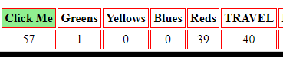  
      
    and as the steps proceed, keeping an eye on GREENS will show how fast the population is depleting, while the number of YELLOWs and BLUEs show the size of the hidden infected population.  
      
    However, SHOW CHART button calculates charts in canvas.js and this is why the program needs to be connected to the Internet because of the calls to the libraries.  
      
    Clicking on the SHOW CHART will display the charts below the Action Field. To see them, scroll below the action field. However, SHOW CHART button calculates charts in canvas.js and this is why the program needs to be connected to the Internet because of the calls to the libraries.

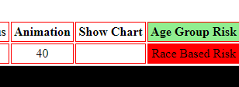

CHARTS WITHOUT AGE RISK PROFILES

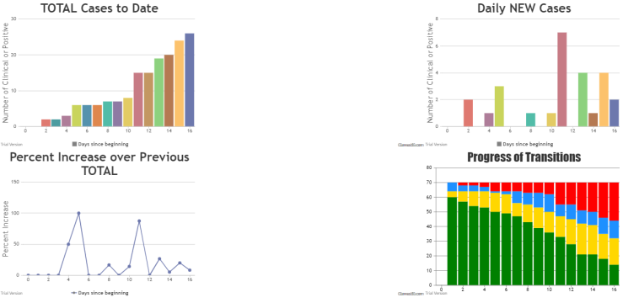

Very simply, the first shows the Total Cases (REDs) as time intervals proceed from left to right.

The second on the right shows the Daily New Cases, which gives an indication of the rate of growth of the epidemic. It is # New Cases / # cases of previous day.

The third shows the % increase over the previous day. Thus, if on Day 1 there were 100 cases, and on Day 2 there were 120 cases, the new cases are 20 and the % increase is 20/100 or 20%. At 20% increase over the previous per day, the cases double in about 3-4 days. That’s compound interest for you. You can use the mouse to span a region of the line graph and zoom, and then pan that area.

The fourth is the Stacked Bar chart of overall progress, showing the mix of GREEN, YELLOW, BLUE, RED at each step from T=0 on the left to T++ on the right. Note that the hidden YELLOW and BLUE infected are generally larger than REDs in the initial part of the epidemic.

WITH AGE RISK

An additional chart is produced for Age-Risk, and this is also a Stacked Bar Charts using canva.s.js.

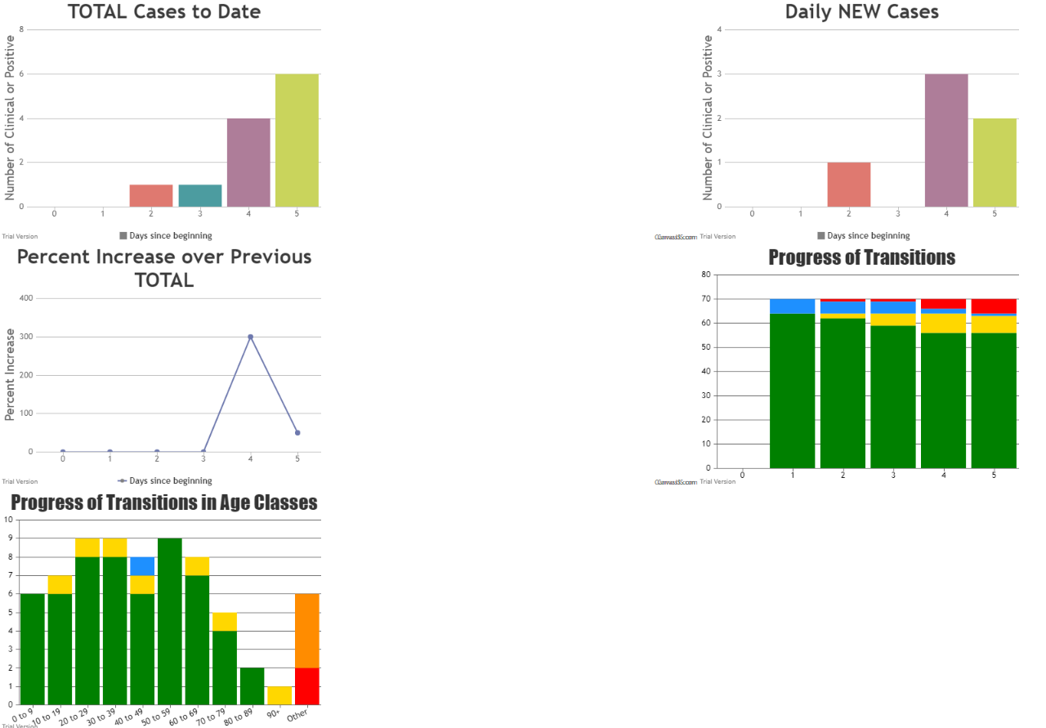

The charts above were produced in a trial with these settings:



Only 5 steps have been taken. There were 64 initial GREENS, and 6 BLUEs were added after the census of Age-Groups. These show up in the last graph as “OTHER” of which at this time 5 had already turned to ORANGE from RED, and one is still in the RED state.

The overall progress at each step of Greens, Yellows, Blues and Reds are shown in Graph 4 (second row right) and at each step, one can see that the hidden infected are greater than the found Reds. In this graph, Oranges are not shown separately.

The last graph will show that for the different Age-Groups and susceptibilities, that the younger groups tend to be less infected than the others. The actual chart is interactive in that the mouse-over shows numerical detail that is difficult to capture here, but for an example.

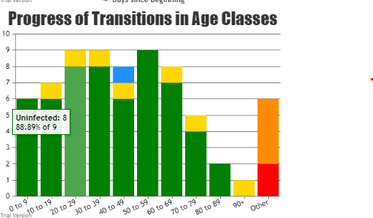

For the 20 to 29 Age Group, (GREEN more muted as selected), the mouse tip tool shows that 8 of 9 are uninfected for a survival rate of 88.89%. At this point, things being stochastic, the 50-59 age-group, the 80-89 age-group, and the 0 to 9 age-group have all yet to be infected.

The 6 Visitor BLUES, listed as “OTHER” of course are further along in the transition than the others, since there are 7 days before the YELLOWS turn into BLUES. Stochastically, one of them has, since their assignment of Incubation Days has a random factor attached.

Of the 6 visitors, 5 of them have turned from RED to ORANGE, and one still is in the RED state.

THAT’S IT for EXPERIMENTAL EPIDEMIOLOGY

Hopefully you find this simple. Some cases to try: (use Age-Risk then add BLUEs)

P=100 Travel=50 Incubating Days=7 Infectious Days=5 Hazard Ratio=40 Infection Mode=0

See how many cycles to get to end of epidemic (no more YELLOW, BLUE or RED)

Try it with Mode=3 with factor of 1.2

Try it with Mode=3 with factor of 0.5

Try these and after Step 5, cut Hazard Radius to 2; keep reducing in trials

Try p=1600 B=10 Hazard Ratio= 2 Travel=5 if the epidemic is not self-limiting, try Mode=3 with X=0.7

Some Thoughts

This tool can easily model different levels of epidemics, and the discrete time-steps and visualization permit the monitoring of the progress at each step. Furthermore, the simulator permits the modification of paramters at any step, so that one could use this to see the effect of interventions in the reduction or growth of the epidemic.

*Self-limiting Epidemics*

For example, a slow self-limiting epidemic can be simulated using the parameters:

Pop=100; use Age-Risk; add 2 BLUEs; Travel=3; Incuba=2; Infectious=1 Mode=0 Hazard=20 Red=1

This clearly extinguishes; however, adding 10 BLUES will also be self-limiting (try it); adding 20 BLUES as well!

*Explosive Epidemics*

Try this exponential growth setting:

Pop=100; use Age-Risk; Travel=60; Incub=7; Inffect=1; Mode=0; Hazard=35

Generally, after stabilizing YELLOW=0 BLUE=0 there are 0 to 3 survivors…

Intervention in the Explosive Epidemic

This can be done either by changing assumption (for example, that BLUE infectivity is constant or increasing). Suppose you set mode=3 and multiplicative factor to 0.5 (decreases by half every step). You may find the results instructive.

However you can use this to try implementing POLICIES (one trial at a time):

1. Reduce Travel; set it to 1 at step 5 before it has exponential growth
2. Reduce infectious days (MORE TESTING) – set it to 1 at step 5
3. Reduce incubating days by CONTACT TRACKING – set it to 1 at step 5
4. Increase shelter-at-home lockdown: set Hazard to 2 or 1 (can’t see with 1 – follow numbers)
5. Use some combination of the above

At any of these settings, you can go one step at a time and look at the Charts….one thing that you should find is that by and large, the Age-Risk modelling is relatively true to Model Risk influence. The thing to look for is the Green % left in each Age category, and this you find at present by using the mouse to ToolTip over the colored bars for an Age-Group.

Retro-fitting Models to Known Epidemics

The curve of epidemics in each country has been followed in the CovidCharts that I created faithfully for months. Although they all have the same general curve, there are specific differences, and whether the CovidSim is close to, or can be driven by their data, is a question whose answer eludes me at this point.

HELP ME IF YOU HAVE INSIGHTS INTO HOW AN AGENT-BASED MODEL CAN RELATE TO REALITY AND BE A USEFUL PREDICTION TOOL.

Turing Tape

START=5;BLUES=3;TRAVEL=5;INCUBATE=3;INFECT=4;MODE=3;FACTOR=0.7;HAZARD=10;

Anxiety Disorders, Rapid Access Addiction, Opiod Agonist Therapy, Acute Hospital Care, Emergency Department, USTAT, Psychosocial Rehab, Medical Detox, Assertive Community Treatment

*****************************************************************

WorkStaffHiClientHi, WorkStaffHiClientLo, WorkStaffLoClientHi, WorkStaffLoClientLo, RecHiMix, RecLoMix,

WorkStaffHiClientLo: meatpacking, manufacturing, military, warehouses, kitchen staff, commercial fishing, corporate offices, large IT office

WorkStaffLoClientHi: conventions, airports, trains, buses, rallies, professional sports, restaurants, gyms, bars, hospitals, nursing homes, doctor offices, dentists, ERs, retail chains, malls, coffee houses, casinos, swimming pools, theaters, hotels, aquariums, border crossings

WorkStaffLo, ClientLo: repair garages, construction, house painting, gardening, plumbing, personal training, physiotherapists, personal services (nails, hair, massage), gas bars, small offices (insurance, music production studios, small media companies, accounting)

WorkStaffHiClientHi: cruise ships, Las Vegas (security, food services, dealers, cleaning, entertainment, hotels, maintenance, management), entertainment complexes, politician complexes (Congress, Senate, House), resorts

RecreationMingle

RecreationSpacing

NuclearFamily

SharedHousing

Shopping

Persons move from Home 🡪 work 🡪 recreation 🡪 shopping 🡪travel 🡪 Home

Different examples from each class would have different characteristic mingle and risk patterns (age, susceptibility)…..through different travel patterns…..

(140 word) – 793 characters spaces not counted.

This research will create tools for alternative interventions as Covid-19 progresses, through better modelling of asymptomatics, and the dynamics of mingling of varying population densities and risks.

The project has three arms; the first uses classic meta-population patch and Agent-Based Models to various mixes of transient and resident populations of different risk profiles.

The second arm is the creation of an extensive contact tracing tool, which will be able to follow the positive cases through several degrees of separation, and any increased risk to vulnerable populations.

The third is to create better estimates for hidden populations of infected asymptomatic patients, as the population is randomly tested, through techniques used in wildlife ecology.

The total budget is $250,000 covering research assistants in all three arms (six in total). They will be managed by the co-PIs from Island Health Authority and UVIC.

